Lesson 4 Demo 4: Create a Macvlan Network

This section will guide you to:

* Create a Macvlan network in bridge mode
* Create an Alpine container and attach it to the Macvlan network

**Step 1:** Create a Macvlan network in bridge mode

* Create a Macvlan network in bridge mode with subnet, gateway, and parent values

*sudo docker network create -d macvlan *

*--subnet=172.16.86.0/24 *

*--gateway=172.16.86.1 -o *

*parent=docker0 macvlan-net*

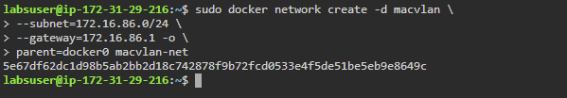

* List all the networks to check the newly created macvlan network

*sudo docker network ls*

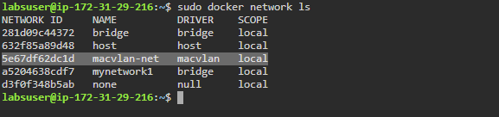

* Inspect the macvlan network and check the **Driver** type

*sudo docker network inspect macvlan-net*

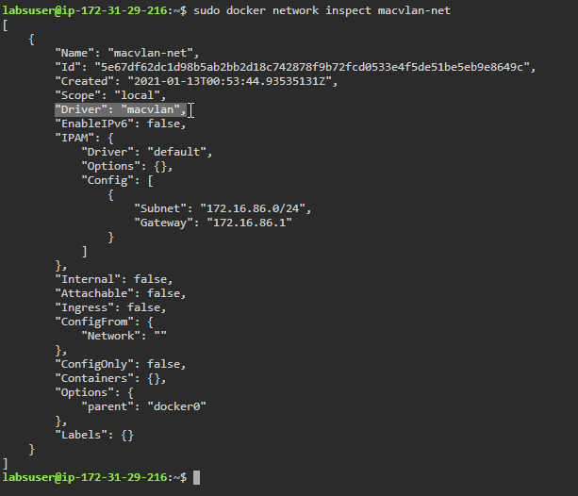

**Step 2:** Create an Alpinecontainer and attach it to the Macvlan network

* Start an **Alpine** container and attach it to the *macvlan-net* network

*sudo docker run --rm -dit *

*--network macvlan-net *

*--name macvlan-alpine alpine:latest ash*

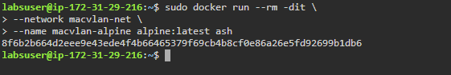

* Inspect the *macvlan-alpine* container and observe **MacAddress** key in the **Networks** key

*sudo docker container inspect macvlan-alpine*

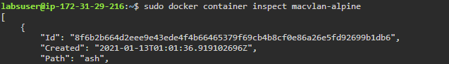

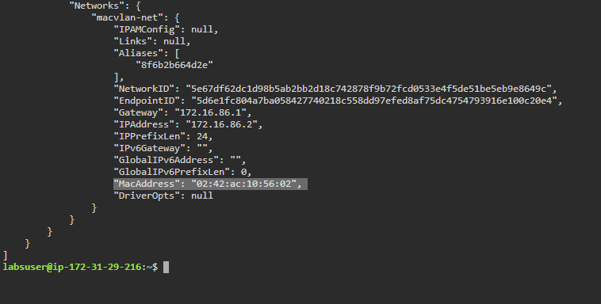

* Run the following command to check how the container sees its network interfaces:

*sudo docker exec macvlan-alpine ip route*

